Networks and Graphs: Program Evaluation and Review Technique (PERT)
Charts
VII.D Student Activity Sheet 12: Building a Robot

You are leading a group that is designing and building a robot; the group is divided into several teams. The following table indicates the different activities that go into this complex process, which teams are in charge of which activities, the number of individuals from that team dedicated to that activity, how long the activity will likely take, and which activities must be completed before an activity can be started.

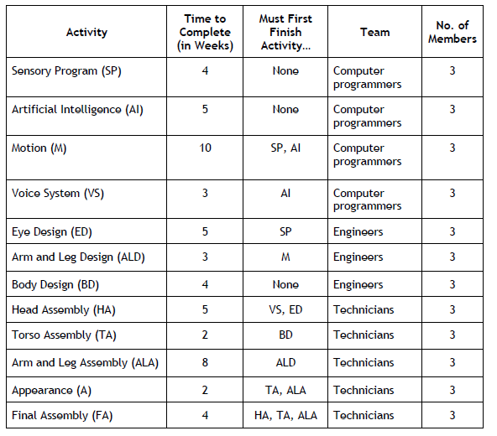

1. Using the information in the first three columns of the table, build an activity graph. Include Start and Finish boxes.

2. Assuming the times given for each activity are accurate, what is the minimum time required to design and build the robot?

3. At what point in the timeline does each activity (for the completion of the entire robot) begin and end?

4. Which of the 12 activities are critical activities?

5. EXTENSION: Since any delay in the completion time for critical activities results in a longer total completion time, these activities may need extra people assigned to them. Suppose you can reassign team members to an activity according to the following guidelines:
No one can work on an activity outside of his/her team. For example, a computer programmer must be assigned to Activity 1, 2, 3, or 4 and cannot be assigned to any of the other activities.
Every activity must have at least one person assigned to it at all times.
An activity that receives extra help can be completed 1 week earlier for each additional person assigned to it.
An activity cannot be completed in less than 1 week, even if more people are assigned to it.
An activity takes 1 week longer to complete for each person removed from the original group.
a. If you could reassign one person, how would you do it? How does the reassignment affect the total completion time?
b. If you could reassign two people, how would you do it? How do the reassignments affect the total completion time?
c. If you could reassign any number of people, how would you do it? How do the reassignments affect the total completion time?

6. REFLECTION: Could the total completion time be further improved by allowing people to work on activities outside of their official team designation? Justify your response with appropriate reasoning.

