Networks and Graphs: Graph Coloring
VII.C Student Activity Sheet 9: Map Coloring

Map Coloring Problem

You are the publisher of a new edition of the world atlas. As you prepare the different maps for printing, you need to make sure that countries adjacent to each other (sharing a common border) are given different colors.

1. For the following two maps, decide how to color each of the five countries (regions) so that no two adjacent countries are colored the same. Treat the outside region as a single country (perhaps it represents an ocean colored blue). Assume that every country is composed of a single contiguous region (for example, you treat Alaska and Hawaii as separate regions when constructing a map of the world).

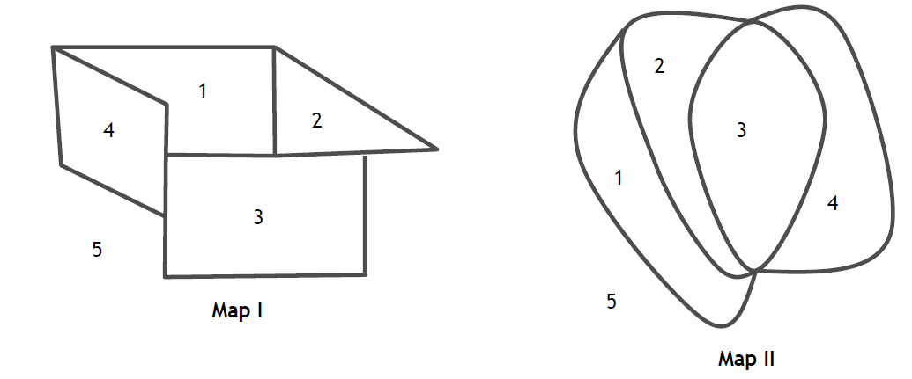
2. How many colors did you use to color each map?

3. REFLECTION: Did you use fewer colors than anyone else? If not, describe how you can adjust your map to use fewer colors. If yes, how are you confident that the fewest colors have been used that can be?

4. If you want to color each map using the least number of colors (still keeping adjacent regions separate colors), how many colors are needed for each map?

5. Create a map that requires the use of three colors.

6. Create a map with at least four different regions that could be colored with two colors.

7. EXTENSION: Create a map that needs five colors. What is the largest number of colors required to color any map, that keeps adjacent regions separate? Justify your response.

