Networks and Graphs: Graph Coloring
VII.C Student Activity Sheet 10: Coloring Maps and Scheduling

Creating Graphs from Maps
1. Revisit the map coloring exercises from Student Activity Sheet 9 in terms of graphs. For example, Map I can be represented by the following graph. The graph should include a vertex for each country (or region) in your map. If two countries share a border and need to be colored differently, the graph shows an edge between the vertices that represent them.

After studying the relationship between Map I and the graph for Map I, create a graph that represents Map II.
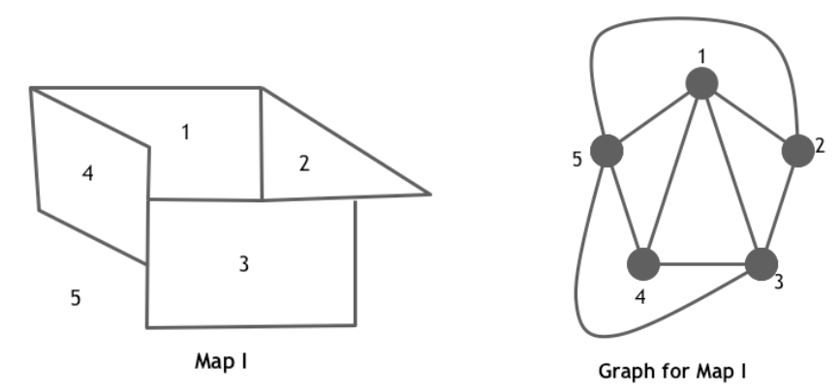

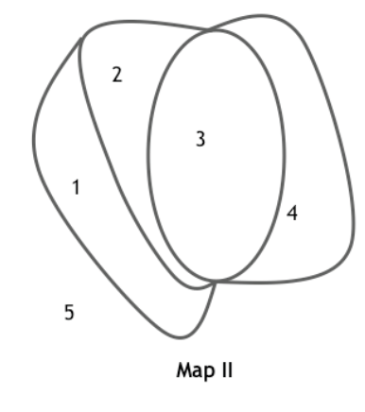
2. Restate the Map Coloring problem from Student Activity Sheet 9 in terms of a Graph Coloring problem.
You are the publisher of a new edition of the world atlas. As you prepare the different maps for printing, you need to make sure that countries adjacent to each other (sharing a common border) are given different colors.

3. Create a graph that requires three colors.

4. Create a graph that could be colored with two colors.

5. What types of graphs can always be colored with two colors?

6. EXTENSION: Create a graph that needs five colors, and then draw the associated map.

7. REFLECTION: When might a graph not correspond to a map?

8. The chromatic number of a graph is the minimum number of colors needed to color each vertex in such a way that any two vertices sharing an edge are a different color. Provide examples of graphs that have chromatic numbers of 3 and 4.

9. Give an example of a graph with 20 vertices that has a chromatic number of 2. Does your graph have any cycles? (Recall: A cycle is a path through the graph that starts and ends at the same vertex and does not reuse any edges.)

Scheduling Problem
Mrs. Jacobs, the new principal at Riverdale High School, wants to make a good impression by offering a lot of new exciting classes for her students. The principal plans to use her knowledge of graph theory to determine when each class will be offered. Since she is trying to make her students happy, Mrs. Jacobs does not want to offer two different classes at the same time if there are students wanting to take both. She decides to construct a graph in the following way: Each class is represented by a vertex and if there is a student interested in two classes, those two vertices are connected by an edge.

10. Suppose there are five classes (A, B, C, D, and E) and only five students wishing to take the following classes:
Jason wants to take Classes A and E.
Emory want to take Classes B, C, and E.
Felicity wants to take Classes A and D.
Geoff wants to take Classes B and C.
Hilary wants to take Classes D and E.

Construct the graph for the principal.

11. Find the chromatic number of the graph, and color the graph using the least number of colors.

12. How can the graph coloring solution help the principal with her scheduling problem?

13. EXTENSION: Select another situation that might be modeled with colored graphs. Several suggestions are described to stimulate your research. Prepare a short presentation of your findings to share with the class. The notion of coloring graphs can be used to solve a variety of problems involving various types of conflicts over space or time. Some examples include the following:
Conflict over time: Virtually any type of scheduling problem such as appointments or job duties based on an individual’s qualifications.

Conflict over space: 1) Create several terrariums to display a variety of plants and reptiles. Certain reptiles may not get along with others, and certain plants should not be placed in terrariums with certain reptiles. Based on a set of compatibility conditions, you could decide the minimum number of terrariums necessary for the exhibit. 2) Radio stations that are within a certain distance of each other cannot be assigned the same broadcasting frequency. Given several radio stations and the distances between each pair, determine the minimum number of distinct frequencies necessary to allow all stations to operate.

Other conflicts: Put a roomful of people into small working groups. Each individual may have a list of others with whom he/she does not work well, thereby disallowing them to share a group. Given each person’s “Cannot Work With” list, how many groups are necessary?

Chemistry: Certain chemicals cannot be stored with other chemicals. For example, to answer the question regarding how many storage facilities are required to house the following chemicals, graph coloring can be helpful.

