Networks and Graphs: Spanning Trees
VII.B Student Activity Sheet 6: High-speed Internet

Your company must run Ethernet cables to five different offices so that all five offices have high-speed Internet access. For each computer to be on the office network, there must be a way to get from each computer to the other computers by following the cable.

1. One worker proposed running cable between the five offices as illustrated in the
following diagram. The vertices represent the offices, and the edges represent segments
of cable.
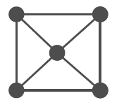
How many lengths of cable (edges) are used? Explain why this an inefficient way to run the cable.

2. Design a more efficient network and indicate how many lengths of cable are used.

3. Compare your efficient network with others in the class.
a. Did everyone use the same number of cable lengths?
b. Did everyone’s network have the same shape?

4. A cycle in a graph is a path that starts and ends at the same vertex and does not use any edge more than once.
a. Identify two cycles in the graph from Question 1.
b. Does your network from Question 2 have any cycles? Should it?
c. What does the existence of cycles tell you about the efficiency of a network?

5. REFLECTION: Describe how a cycle is similar to an Euler circuit.

6. Write a set of step-by-step instructions to form an algorithm for converting an inefficient network into an efficient network.

7. Have another student apply your algorithm to the following inefficient network and indicate the number of edges in the final efficient network.

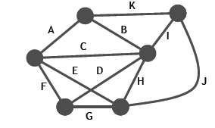
8. EXTENSION: Research other situations that might be modeled with graphs in such a way that cycles become important. Draw an efficient network for the situation (not a cable connection, of course!). Prepare a short presentation for the class.

Use the following questions as needed:
Do all graphs have cycles?
Are the cycles unique?

