Networks and Graphs: Circuits, Paths, and Graph Structures
VII.A Student Activity Sheet 4: Hamiltonian Circuits and Paths

A Voyage Around the World

1. Plan a trip around the world by visiting each city exactly once and using only the identified routes to travel from city to city. The dashed lines represent routes on the opposite side of the globe.

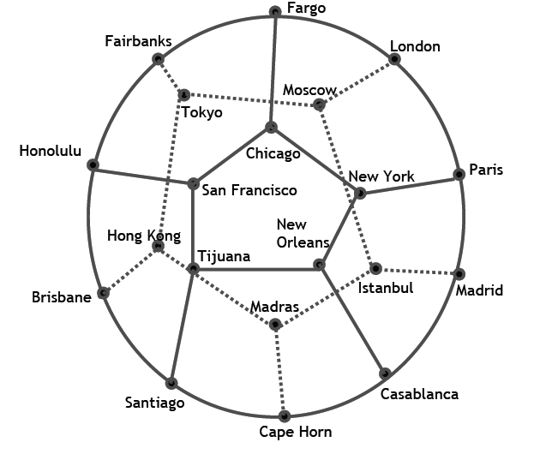

2. A path on a graph that goes through each vertex once is called a Hamiltonian path. A path that starts and stops at the same vertex and goes through each vertex once is called a Hamiltonian circuit. Which of the following graphs have a Hamiltonian circuit?

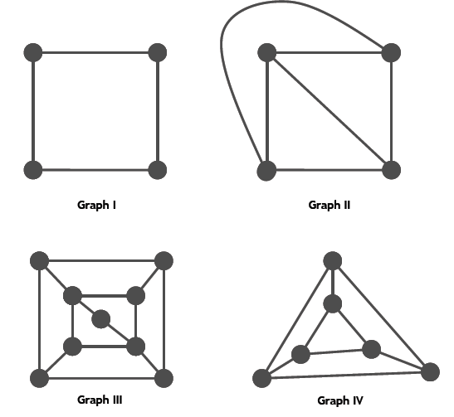

3. Form a conjecture about when you think a graph might have a Hamiltonian circuit.

4. Share your conjecture with others and try to find examples of graphs that disprove your conjecture. These are called counterexamples.

5. REFLECTION: Compare and contrast a Euler circuit and a Hamiltonian circuit.

6. EXTENSION: Describe a situation (other than travel) that requires a Hamiltonian circuit exist, but not a Euler circuit. Include either a diagram and graph or similar diagrams that show the connection of the graph to the real situation. Provide any details necessary to connect to the real-world application of this learning.

