Networks and Graphs: Circuits, Paths, and Graph Structures
VII.A Student Activity Sheet 3: Weighted Graphs

The Snowplow Problem
As the new snowplow operator, you must decide the best route through three cities. In each city, you need to plow all the roads and return to your starting place, but you must also keep from backtracking as much as possible.

1. Construct two snowplow routes through each of the following cities and indicate the time it will take to travel each route. The time it takes to traverse each road (in hours) is indicated in the graph.
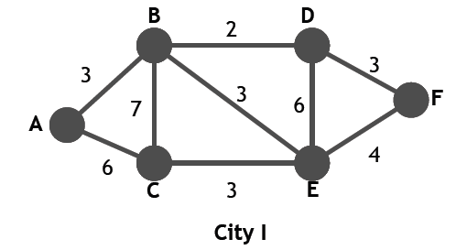
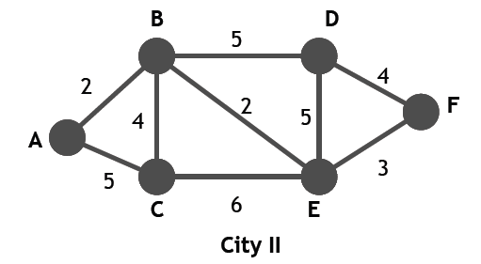
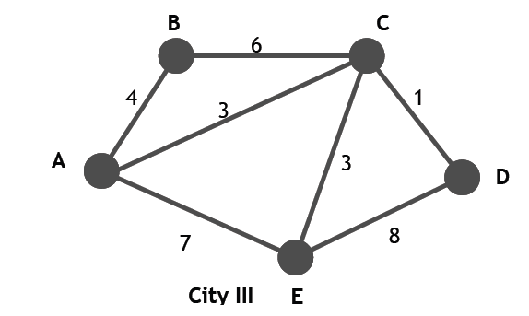
2. REFLECTION: How would you solve the Snowplow problem for a graph that has no vertices of an odd degree?

3. City I has two vertices of an odd degree.
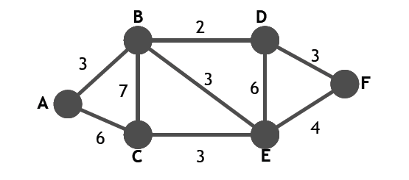
a. Find these vertices and the shortest path between them.

b. For each edge in this shortest path, put in a second copy of the edge.

c. At this point, your graph should have no vertices of an odd degree. Find a Euler circuit and compare this path with the paths you found for City I.

4. Follow the procedure outlined in Question 3 to find a solution to the Snowplow problem
for City III.
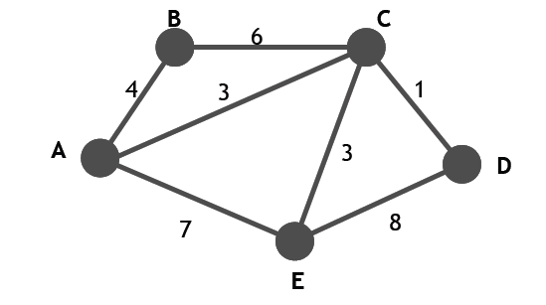
5. EXTENSION: Prior to the beginning of school, a huge task occurs at almost every school in the nation—cleaning the floors! Whether it be waxing, steam cleaning, or mopping, it is critical that the floors be ready for the first day of school. Your task is to design the plan for this cleaning project.
- Draw a graph of the hallways in your school or portion of your school (at least six edges).
- Assign weights to each edge according to the width and length of the corresponding hallway and how long it will take to complete that edge or hallway.
Design a path through your school or portion of your school and determine the total number of hours required to complete the cleaning of the floors. Be prepared to share your design with the class.

