Networks and Graphs: Circuits, Paths, and Graph Structures
VII.A Student Activity Sheet 2: Dominoes

Dominoes are rectangular tiles divided into two squares. Each square has a number (usually represented by a series of dots) from 0 to 6. A double-six set of dominoes has tiles of every possible combination of these numbers, from 0–0 to 6–6. Each possible combination of numbers appears only once in a set, so a complete set of dominoes contains 28 tiles. Two tiles from a double-six set of dominoes are shown below:

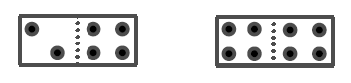

In many games, you must place the dominoes next to each other in such a way that squares
with identical numbers are placed next to each other. Doubles are traditionally rotated
before they are placed. Adhering to these rules, the following shows a legal placement of
three dominoes:

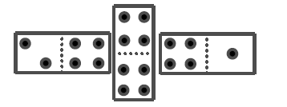

Domino Placement Problem

Can all the dominoes in a double-six set be placed in a single line of tiles adhering to the placement rules previously described? Can they all be placed so that the single line loops back to the first domino? The remainder of this activity sheet will help you answer these questions.

1. Decide how to use a graph to model the Domino Placement problem. Carefully define what your vertices represent and how you know when two vertices are connected by an edge.

2. Based on your model, restate the Domino Placement problem.

3. What type of previously solved problem in this unit is this problem related to?

4. Solve the Domino Placement problem.

