Networks and Graphs: Circuits, Paths, and Graph Structures
VII.A Student Activity Sheet 1: Euler Circuits and Paths

The Königsberg Bridge Problem
The following figure shows the rivers and bridges of Königsberg. Residents of the city occupied themselves by trying to find a walking path through the city that began and ended at the same place and crossed every bridge exactly once.
1. If you were a resident of Königsberg, where would you start your walk and what path would you choose?

2. What about when you visit the Eastern and Western wildflower gardens that have fabulous sculptures in addition to beautiful flowers along the walkways. You want to see each display without backtracking (seeing something you have already seen). Where would you start your walk and what path would you choose?

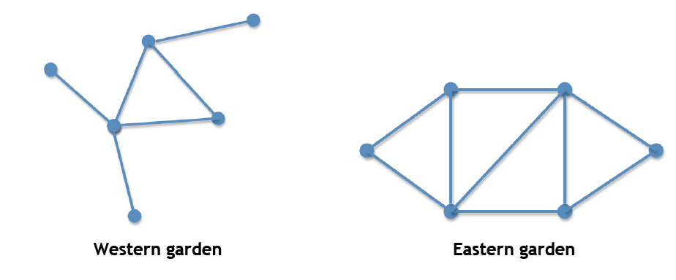
When Leonhard Euler, a famous mathematician, turned his attention to the Bridge problem, his first step was to model the bridges of Königsberg with a simple graph. The points, or vertices, represented land and the edges represented the bridges connecting them. Euler’s map of Königsberg, while much simpler, conveyed all the necessary information about which parts of land were connected by which bridges. It looked something like the following:
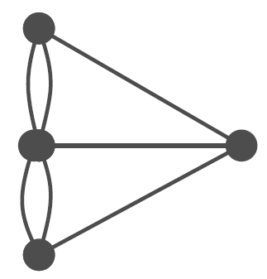

The Bridge problem is now stated: Given a graph, find a path through the vertices (points) that uses every edge exactly once. Such a path is called a Euler path. If a Euler path begins and ends at the same vertex, it is called a Euler circuit.

3. For the following graphs, decide which have Euler circuits and which do not.

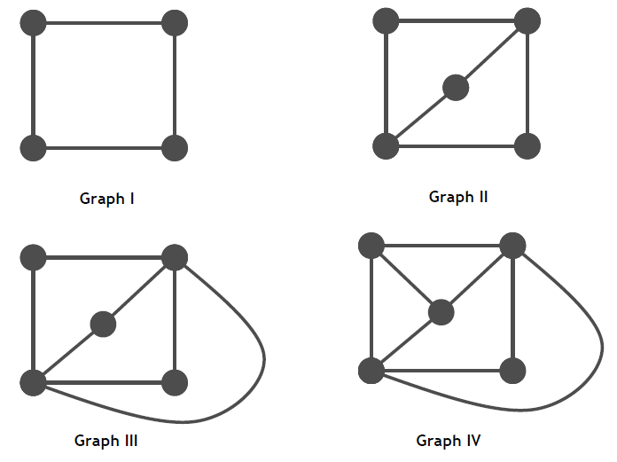
4. The degree of a vertex is the number of edges that meet at the vertex. Determine the degree of each vertex in Graphs I–IV.

5. For the graphs from Question 3 that have Euler circuits, how many vertices have an odd degree?

6. For the graphs from Question 3 that have Euler circuits, how many vertices have an even degree?

7. Form a conjecture about how you might quickly decide whether a graph has a Euler circuit, and explain why your conjecture seems reasonable.

8. What does your conjecture tell you about the Königsberg Bridge problem and the garden scenario?

9. Your friend Chet calls you on his cell phone and tells you that he has discovered a large rock embedded with gems! He is somewhere in your favorite hiking area, which has many interconnected paths, as shown below. Chet does not know exactly where he is, but he needs your help to carry the rock. To find him, you decide it would be most efficient to jog along all the paths in such a way that no path is covered twice. Find this efficient route on the map below or explain why no such route exists.
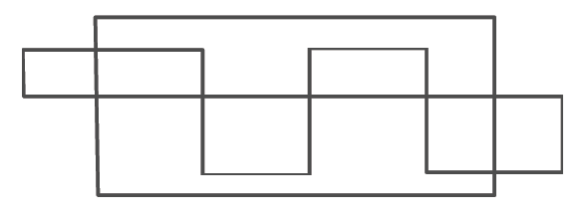

10. You have been hired to paint the yellow median stripe on the roads of a small town. Since you are being paid by the job and not by the hour, you want to find a path through the town that traverses each road only once. In the map of the town’s roads below, find such a path or explain why no such path exists.

11. REFLECTION: For what situation(s) is it satisfactory to have only a path exist and not a circuit?

12. EXTENSION: Determine some other real-world problems whose solutions may involve finding Euler circuits or paths in graphs. There are a variety of road-traversing problems: delivering mail, garbage/recyclable collecting in a city, sweeping/cleaning streets, and so on. For each situation, describe what real-world complications exist that might make the problem more difficult. For example, when delivering mail, most streets have houses on either side of the street and the postal worker may decide to go up one side of the street and down the other. If the city has alleyways, perhaps the garbage collectors just need to travel down the alleys. Be prepared to make a short presentation of your findings to the class.

