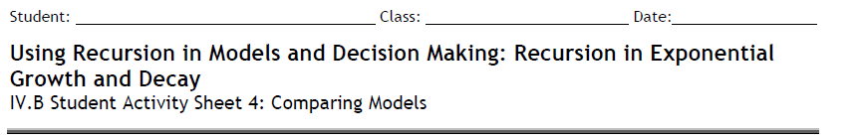
Derrick is trying to save money for the down payment on a used car. His parents have said
that, in an effort to help him put aside money, they will pay him 10% interest on the money
Derrick accumulates each month. At the moment, he has saved $200.
1. Suppose Derrick does not add any money to the savings. Write a recursive rule and an
explicit function rule that model the money Derrick will accumulate with only the
addition of the interest his parents pay.

2. How long will it take Derrick to save at least $2,000 for the down payment if the only
additions to his savings account are his parents’ interest payments?

3. In an effort to speed up the time needed to save $2,000, Derrick decides to take on some
jobs in his community. Suppose he commits to adding $50 per month to his savings,
starting with the initial deposit from his parents. Fill in the table, showing the amount of
money Derrick will have over several months.
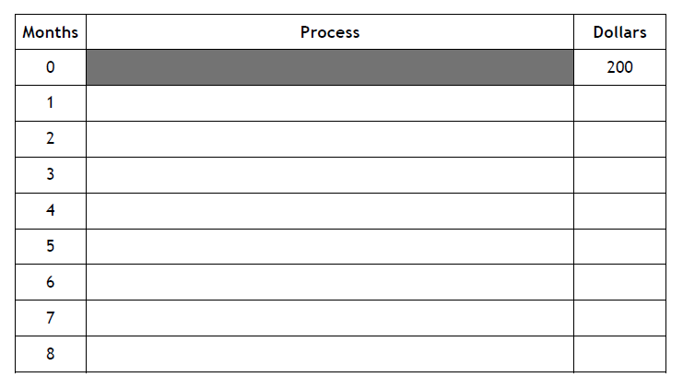
4. Make a scatterplot of the data you generated in the table and compare the scatterplot to
the function rule you found for Question 1. How does adding $50 per month to Derrick’s
savings change the way in which his money grows?

5. How long will it take Derrick to save $2,000 for the down payment if he continues to add
$50 every month? Explain how you arrived at your answer.

6. REFLECTION: How would you write a recursive routine to model this situation? A function
rule? Explain your reasoning for each type of rule and compare your responses.

7. EXTENSION: Suppose Derrick changes the amount of money he adds to his savings each
month to $100. How does this affect the time it takes to save $2,000? How much does he
have to add to the savings each month to have enough money for the down payment on
his car in six months? Explain your responses.

